Chapter 5: Multiple-Table Queries
Solutions
Answers to Review Questions
1. Indicate in the SELECT clause all columns to display, list in the FROM clause all tables to join, and then include in the WHERE clause any conditions requiring values in matching columns to be equal.
2. You must qualify names if the same name appears in more than one of the tables listed in the FROM clause. You qualify column names using the following format: table name.column name.
3. IN and EXISTS.
4. Nested subqueries refers to a subquery within a subquery. The innermost subquery is executed first.
5. An alias is an alternate name for a table. To specify one in SQL, follow the name of the table with the name of the alias. You use the alias just like a table name throughout the SQL command.
6. List the table twice in the FROM clause, using two different aliases. Use these aliases in both the SELECT clause and in the condition in the WHERE clause that relates the tables.
7. Use the UNION, INTERSECT, and MINUS operators to create a union, intersection, and difference of two tables. To perform any of these operations, the tables must be union-compatible.
8. Two tables are union-compatible if they have the same number of columns and if their corresponding columns have identical data types and lengths.
9. If a subquery is preceded by the ALL operator, the condition is true only if it is satisfied by all values produced by the subquery.
10. If a subquery is preceded by the ANY operator, the condition is true if it is satisfied by any value (one or more) produced by the subquery.
11. In an inner join, only matching rows from both tables are included. You can use the INNER JOIN clause to perform an inner join.
12. In a left outer join, all rows from the left table (that is, the first table listed) are included whether or not they match (that is, satisfy the matching condition in the WHERE clause). Only matching rows from the right table are included. You can use the LEFT JOIN clause to perform a left outer join.
13. In a right outer join, all rows from the table on the right will be included regardless of whether they match rows from the table on the left. Rows from the table on the left will be included only if they match. You can use the RIGHT JOIN clause to perform a right outer join.
14. The formal name is Cartesian product. To form a product of two tables, include both tables in the FROM clause and omit the WHERE clause.
15. [Critical Thinking] Answers will vary. Answers should note that an equi-join is similar to an inner join except that both matching columns appear in the results. A natural join is the same as the inner join discussed in this chapter. A cross join is the same as a Cartesian product.
16. [Critical Thinking] Answers will vary. Answers should mention that cost-based query optimizers assign an estimated "cost" to each possible query execution plan, and choose the execution plan with the smallest cost. Queries that join three or more tables benefit from a cost-based query optimizer.

Answers to TAL Distributors Exercises

1.
SELECT ORDER_NUM, ORDER_DATE, ORDERS.CUSTOMER_NUM, CUSTOMER_NAME
FROM ORDERS, CUSTOMER
WHERE ORDERS.CUSTOMER_NUM = CUSTOMER.CUSTOMER_NUM;
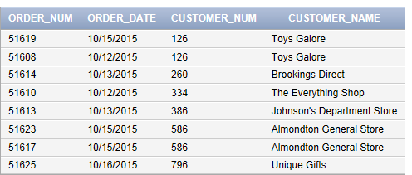

2.
In Oracle and SQL Server, the command is:
SELECT ORDER_NUM, ORDERS.CUSTOMER_NUM, CUSTOMER_NAME
FROM ORDERS, CUSTOMER
WHERE ORDERS.CUSTOMER_NUM = CUSTOMER.CUSTOMER_NUM
AND ORDER_DATE = '10/15/2015';
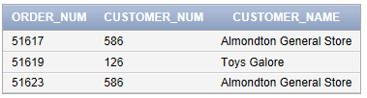

In Access, the command is:
SELECT ORDER_NUM, ORDERS.CUSTOMER_NUM, CUSTOMER_NAME
FROM ORDERS, CUSTOMER
WHERE ORDERS.CUSTOMER_NUM = CUSTOMER.CUSTOMER_NUM
AND ORDER_DATE = #10/15/2015#;

3.
SELECT ORDERS.ORDER_NUM, ORDER_DATE, ITEM_NUM, NUM_ORDERED, QUOTED_PRICE
FROM ORDERS, ORDER_LINE
WHERE ORDERS.ORDER_NUM = ORDER_LINE.ORDER_NUM;
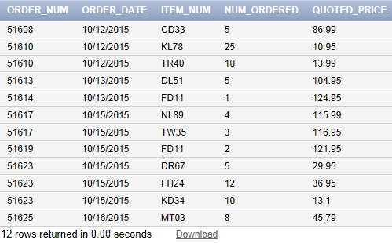

4.
In Oracle and SQL Server, the command is:
SELECT CUSTOMER_NUM, CUSTOMER_NAME
FROM CUSTOMER
WHERE CUSTOMER_NUM IN
(SELECT CUSTOMER_NUM
FROM ORDERS
WHERE ORDER_DATE = ‘10/15/2015’);
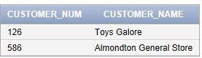

In Access, the command is:
SELECT CUSTOMER_NUM, CUSTOMER_NAME
FROM CUSTOMER
WHERE CUSTOMER_NUM IN
(SELECT CUSTOMER_NUM
FROM ORDERS
WHERE ORDER_DATE = #10/15/20150#);

5.
In Oracle and SQL Server, the command is:
SELECT CUSTOMER_NUM, CUSTOMER_NAME
FROM CUSTOMER
WHERE EXISTS
(SELECT *
FROM ORDERS
WHERE ORDERS.CUSTOMER_NUM = CUSTOMER.CUSTOMER_NUM
AND ORDER_DATE = '10/15/2015');
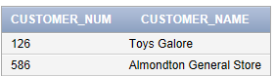

In Access, the command is:
SELECT CUSTOMER_NUM, CUSTOMER_NAME
FROM CUSTOMER
WHERE EXISTS
(SELECT *
FROM ORDERS
WHERE ORDERS.CUSTOMER_NUM = CUSTOMER.CUSTOMER_NUM
AND ORDER_DATE = #10/15/2015#);

6.
In Oracle and SQL Server, the command is:
SELECT CUSTOMER_NUM, CUSTOMER_NAME
FROM CUSTOMER
WHERE CUSTOMER_NUM NOT IN
(SELECT CUSTOMER_NUM
FROM ORDERS
WHERE ORDER_DATE = '10/15/2015');
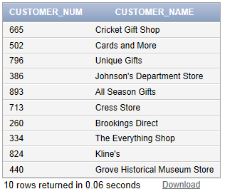

In Access, the command is:
SELECT CUSTOMER_NUM, CUSTOMER_NAME
FROM CUSTOMER
WHERE CUSTOMER_NUM NOT IN
(SELECT CUSTOMER_NUM
FROM ORDERS
WHERE ORDER_DATE = #10/15/2015#);

7.
SELECT ORDERS.ORDER_NUM, ORDER_DATE, ITEM.ITEM_NUM, DESCRIPTION, CATEGORY
FROM ORDERS, ORDER_LINE, ITEM
WHERE ORDERS.ORDER_NUM = ORDER_LINE.ORDER_NUM
AND ORDER_LINE.ITEM_NUM = ITEM.ITEM_NUM;
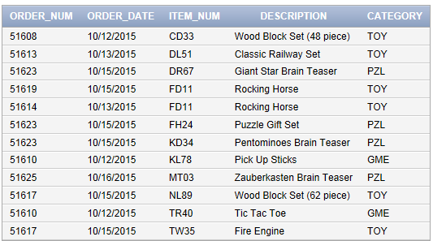

8.
SELECT ORDERS.ORDER_NUM, ORDER_DATE, ITEM.ITEM_NUM, DESCRIPTION, CATEGORY
FROM ORDERS, ORDER_LINE, ITEM
WHERE ORDERS.ORDER_NUM = ORDER_LINE.ORDER_NUM
AND ORDER_LINE.ITEM_NUM = ITEM.ITEM_NUM
ORDER BY CATEGORY, ORDERS.ORDER_NUM;
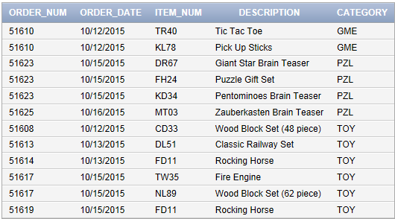

9.
SELECT REP_NUM, LAST_NAME, FIRST_NAME
FROM REP
WHERE REP_NUM IN
(SELECT REP_NUM
FROM CUSTOMER
WHERE CREDIT_LIMIT = 10000);
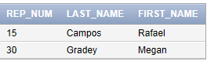

10.
SELECT DISTINCT REP.REP_NUM, LAST_NAME, FIRST_NAME
FROM REP, CUSTOMER
WHERE REP.REP_NUM = CUSTOMER.REP_NUM
AND CREDIT_LIMIT = 10000;

11.
SELECT CUSTOMER.CUSTOMER_NUM, CUSTOMER_NAME
FROM CUSTOMER, ORDERS, ORDER_LINE, ITEM
WHERE CUSTOMER.CUSTOMER_NUM = ORDERS.CUSTOMER_NUM
AND ORDERS.ORDER_NUM = ORDER_LINE.ORDER_NUM
AND ORDER_LINE.ITEM_NUM = ITEM.ITEM_NUM
AND DESCRIPTION = 'Rocking Horse';
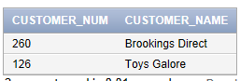

12.
SELECT F.ITEM_NUM, F.DESCRIPTION, S.ITEM_NUM, S.DESCRIPTION, F.CATEGORY
FROM ITEM F, ITEM S
WHERE F.CATEGORY = S.CATEGORY
AND F.ITEM_NUM < S.ITEM_NUM
ORDER BY CATEGORY, F.ITEM_NUM, S.ITEM_NUM;
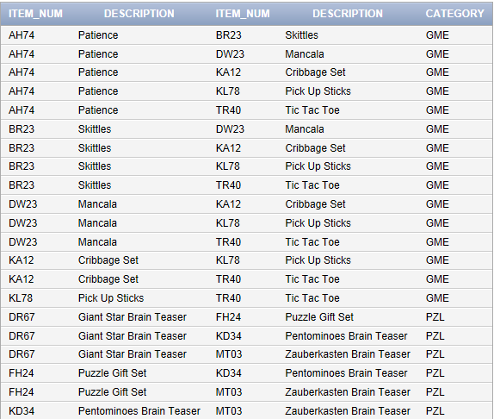
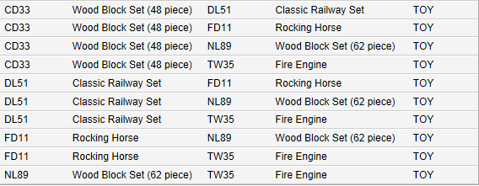

13.
SELECT ORDERS.ORDER_NUM, ORDER_DATE
FROM CUSTOMER, ORDERS
WHERE CUSTOMER.CUSTOMER_NUM = ORDERS.CUSTOMER_NUM
AND CUSTOMER_NAME = 'Johnson''s Department Store';
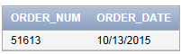

14.
SELECT ORDERS.ORDER_NUM, ORDER_DATE
FROM ORDERS, ORDER_LINE, ITEM
WHERE ORDERS.ORDER_NUM = ORDER_LINE.ORDER_NUM
AND ORDER_LINE.ITEM_NUM = ITEM.ITEM_NUM
AND DESCRIPTION = 'Fire Engine';
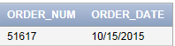

15.
SELECT ORDER_NUM, ORDER_DATE
FROM CUSTOMER, ORDERS
WHERE CUSTOMER.CUSTOMER_NUM = ORDERS.CUSTOMER_NUM
AND CUSTOMER_NAME = 'Almondton General Store'
UNION
SELECT ORDERS.ORDER_NUM, ORDER_DATE
FROM ORDERS, ORDER_LINE, ITEM
WHERE ORDERS.ORDER_NUM = ORDER_LINE.ORDER_NUM
AND ORDER_LINE.ITEM_NUM = ITEM.ITEM_NUM
AND DESCRIPTION = 'Fire Engine';
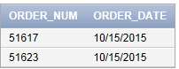

16.
SELECT ORDER_NUM, ORDER_DATE
FROM CUSTOMER, ORDERS
WHERE CUSTOMER.CUSTOMER_NUM = ORDERS.CUSTOMER_NUM
AND CUSTOMER_NAME = 'Almondton General Store'
AND ORDER_NUM IN
(SELECT ORDER_NUM
FROM ORDER_LINE, ITEM
WHERE ORDER_LINE.ITEM_NUM = ITEM.ITEM_NUM
AND DESCRIPTION = 'Fire Engine');
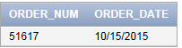

17.
SELECT ORDER_NUM, ORDER_DATE
FROM CUSTOMER, ORDERS
WHERE CUSTOMER.CUSTOMER_NUM = ORDERS.CUSTOMER_NUM
AND CUSTOMER_NAME = 'Almondton General Store'
AND ORDER_NUM NOT IN
(SELECT ORDER_NUM
FROM ORDER_LINE, ITEM
WHERE ORDER_LINE.ITEM_NUM = ITEM.ITEM_NUM
AND DESCRIPTION = 'Fire Engine');
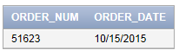

18.
SELECT ITEM_NUM, DESCRIPTION, PRICE, CATEGORY
FROM ITEM
WHERE PRICE > ALL
(SELECT PRICE
FROM ITEM
WHERE CATEGORY = 'GME');
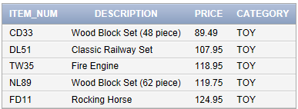
19.
SELECT ITEM.ITEM_NUM, DESCRIPTION, ON_HAND, NUM_ORDERED
FROM ITEM
LEFT JOIN ORDER_LINE
ON ITEM.ITEM_NUM = ORDER_LINE.ITEM_NUM
ORDER BY ITEM.ITEM_NUM;
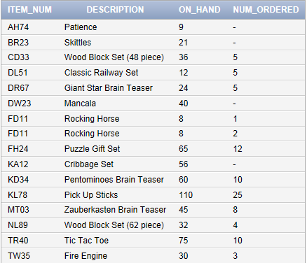

20. [Critical Thinking]
SELECT ITEM_NUM, DESCRIPTION, PRICE, CATEGORY
FROM ITEM
WHERE PRICE > ANY
(SELECT PRICE
FROM ITEM
WHERE CATEGORY = 'GME');

This query answers the question “Which items have a price greater than any price in the category GME?”

21. [Critical Thinking]
SELECT CUSTOMER_NUM, CUSTOMER_NAME, LAST_NAME, FIRST_NAME
FROM CUSTOMER
RIGHT JOIN REP
ON REP.REP_NUM = CUSTOMER.REP_NUM
ORDER BY REP.REP_NUM;

OR

SELECT CUSTOMER_NUM, CUSTOMER_NAME, LAST_NAME, FIRST_NAME
FROM REP
LEFT JOIN CUSTOMER
ON REP.REP_NUM = CUSTOMER.REP_NUM
ORDER BY REP.REP_NUM;
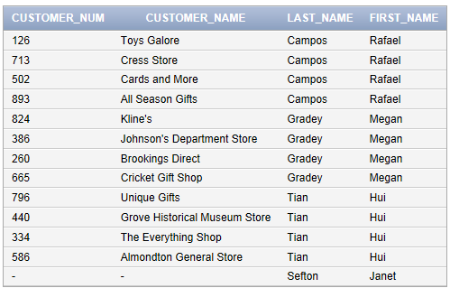

Answers to Colonial Adventure Tours Exercises

1.
SELECT RESERVATION_ID, TRIP_ID, RESERVATION.CUSTOMER_NUM, LAST_NAME
FROM RESERVATION, CUSTOMER
WHERE RESERVATION.CUSTOMER_NUM = CUSTOMER.CUSTOMER_NUM
ORDER BY LAST_NAME;
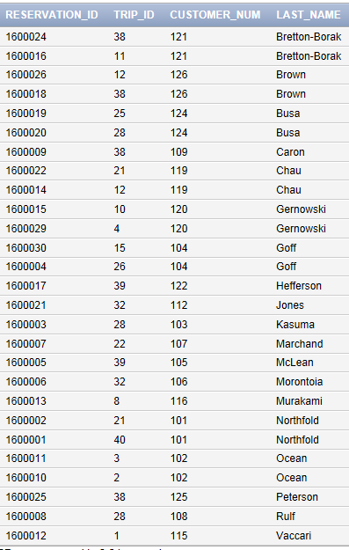

2.
SELECT RESERVATION_ID, TRIP_ID, NUM_PERSONS
FROM RESERVATION, CUSTOMER
WHERE RESERVATION.CUSTOMER_NUM = CUSTOMER.CUSTOMER_NUM
AND LAST_NAME = 'Goff'
AND FIRST_NAME = 'Ryan';
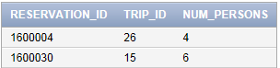

3.
SELECT TRIP_NAME
FROM TRIP, GUIDE, TRIP_GUIDES
WHERE TRIP.TRIP_ID = TRIP_GUIDES.TRIP_ID
AND GUIDE.GUIDE_NUM = TRIP_GUIDES.GUIDE_NUM
AND LAST_NAME = 'Abrams'
AND FIRST_NAME = 'Miles';
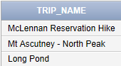

4.
SELECT TRIP_NAME
FROM TRIP, GUIDE, TRIP_GUIDES
WHERE TRIP.TRIP_ID = TRIP_GUIDES.TRIP_ID
AND GUIDE.GUIDE_NUM = TRIP_GUIDES.GUIDE_NUM
AND LAST_NAME = 'Boyers'
AND FIRST_NAME = 'Rita'
AND TYPE = 'Biking';
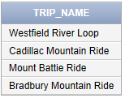

5.
In Oracle and SQL Server, the command is:
SELECT LAST_NAME, TRIP_NAME, START_LOCATION
FROM TRIP, CUSTOMER, RESERVATION
WHERE TRIP.TRIP_ID = RESERVATION.TRIP_ID
AND RESERVATION.CUSTOMER_NUM = CUSTOMER.CUSTOMER_NUM
AND TRIP_DATE = '7/23/2016';
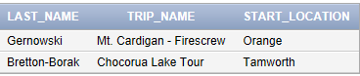

In Access, the command is:
SELECT LAST_NAME, TRIP_NAME, START_LOCATION
FROM TRIP, CUSTOMER, RESERVATION
WHERE TRIP.TRIP_ID = RESERVATION.TRIP_ID
AND RESERVATION.CUSTOMER_NUM = CUSTOMER.CUSTOMER_NUM
AND TRIP_DATE = #7/23/2016#;

6.
SELECT RESERVATION_ID, TRIP_ID, TRIP_DATE
FROM RESERVATION
WHERE TRIP_ID IN
(SELECT TRIP_ID
FROM TRIP
WHERE STATE = 'ME');
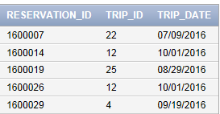

7.
SELECT RESERVATION_ID, TRIP_ID, TRIP_DATE
FROM RESERVATION
WHERE EXISTS
(SELECT *
FROM TRIP
WHERE TRIP.TRIP_ID = RESERVATION.TRIP_ID
AND STATE = 'ME');
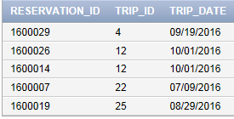
Note: These are the same results but in a different order. To list the reservations in reservation ID order, use the ORDER BY RESERVATION_ID clause at the end of the SQL command.

8.
SELECT LAST_NAME, FIRST_NAME
FROM GUIDE, TRIP, TRIP_GUIDES
WHERE TRIP.TRIP_ID = TRIP_GUIDES.TRIP_ID
AND GUIDE.GUIDE_NUM = TRIP_GUIDES.GUIDE_NUM
AND TYPE = 'Paddling';
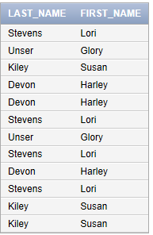

9.
SELECT LAST_NAME, FIRST_NAME
FROM GUIDE G, TRIP T, TRIP_GUIDES TG
WHERE T.TRIP_ID = TG.TRIP_ID
AND G.GUIDE_NUM = TG.GUIDE_NUM
AND TYPE = 'Paddling';

10.
SELECT F.TRIP_ID, F.TRIP_NAME, S.TRIP_ID, S.TRIP_NAME, F.START_LOCATION
FROM TRIP F, TRIP S
WHERE F.START_LOCATION = S.START_LOCATION
AND F.TRIP_ID < S.TRIP_ID
ORDER BY F.TRIP_ID, S.TRIP_ID;
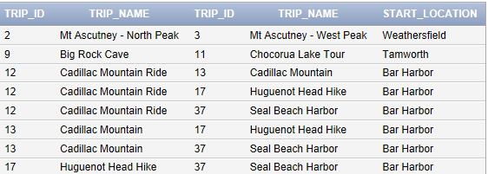

11.
SELECT TRIP_NAME
FROM RESERVATION, TRIP
WHERE RESERVATION.TRIP_ID = TRIP.TRIP_ID
AND TYPE = 'Hiking'
ORDER BY TRIP_NAME;
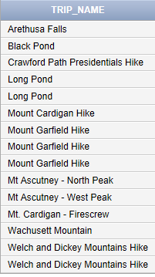

12.
SELECT CUSTOMER_NUM, LAST_NAME
FROM CUSTOMER
WHERE STATE = 'NJ'
UNION
SELECT CUSTOMER.CUSTOMER_NUM, LAST_NAME
FROM RESERVATION, CUSTOMER
WHERE RESERVATION.CUSTOMER_NUM = CUSTOMER.CUSTOMER_NUM;
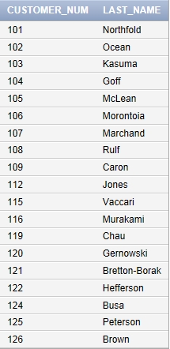

13.
SELECT CUSTOMER_NUM, LAST_NAME
FROM CUSTOMER
WHERE STATE = 'NJ'
INTERSECT
SELECT CUSTOMER.CUSTOMER_NUM, LAST_NAME
FROM RESERVATION, CUSTOMER
WHERE RESERVATION.CUSTOMER_NUM = CUSTOMER.CUSTOMER_NUM;
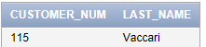

14.
SELECT TRIP_ID, TRIP_NAME
FROM TRIP
WHERE MAX_GRP_SIZE > ALL
(SELECT MAX_GRP_SIZE
FROM TRIP
WHERE TYPE = 'Hiking');
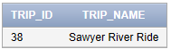

15.
SELECT TRIP_ID, TRIP_NAME
FROM TRIP
WHERE MAX_GRP_SIZE > ANY
(SELECT MAX_GRP_SIZE
FROM TRIP
WHERE TYPE = 'Biking');
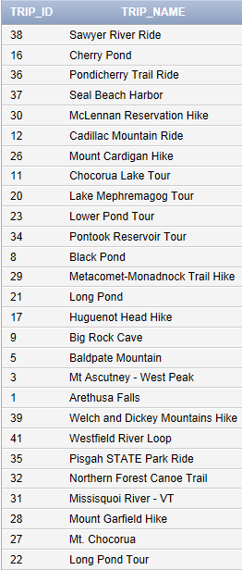

16.
SELECT TRIP.TRIP_ID, TRIP_NAME, RESERVATION_ID
FROM TRIP
LEFT JOIN RESERVATION
ON TRIP.TRIP_ID = RESERVATION.TRIP_ID
ORDER BY TRIP.TRIP_ID;
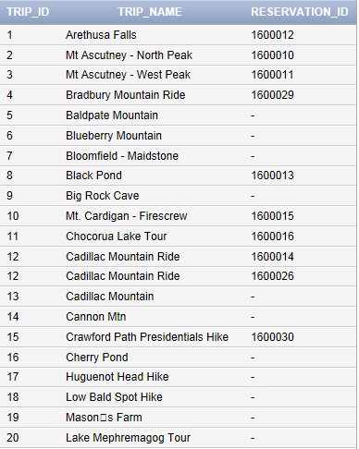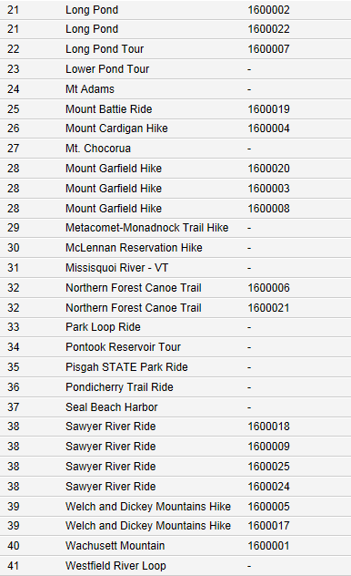

17. [Critical Thinking]
SELECT DISTINCT(LAST_NAME), FIRST_NAME
FROM GUIDE, TRIP, TRIP_GUIDES
WHERE TRIP.TRIP_ID = TRIP_GUIDES.TRIP_ID
AND GUIDE.GUIDE_NUM = TRIP_GUIDES.GUIDE_NUM
AND TYPE = 'Paddling'
ORDER BY LAST_NAME;
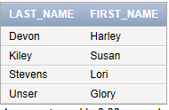

18. [Critical Thinking]
SELECT DISTINCT(TRIP_NAME)
FROM RESERVATION, TRIP
WHERE RESERVATION.TRIP_ID = TRIP.TRIP_ID
AND TYPE = 'Hiking'
AND STATE = 'NH'
ORDER BY TRIP_NAME DESC;
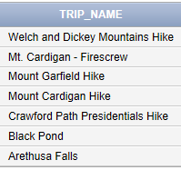

Answers to Solmaris Condominium Group Exercises
1.
SELECT LOCATION_NUM, UNIT_NUM, CONDO_FEE, CONDO_UNIT.OWNER_NUM,
FIRST_NAME, LAST_NAME
FROM CONDO_UNIT, OWNER
WHERE CONDO_UNIT.OWNER_NUM = OWNER.OWNER_NUM;
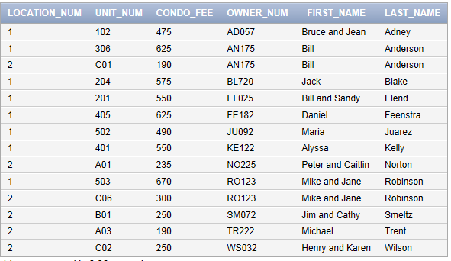

2.
SELECT CONDO_ID, DESCRIPTION, STATUS
FROM SERVICE_REQUEST, SERVICE_CATEGORY
WHERE SERVICE_REQUEST.CATEGORY_NUM = SERVICE_CATEGORY.CATEGORY_NUM
AND CATEGORY_DESCRIPTION = 'Janitorial';
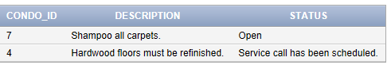

3.
SELECT SERVICE_REQUEST.CONDO_ID, LOCATION_NUM, UNIT_NUM, EST_HOURS,
SPENT_HOURS, CONDO_UNIT.OWNER_NUM, LAST_NAME
FROM SERVICE_REQUEST, SERVICE_CATEGORY, CONDO_UNIT, OWNER
WHERE SERVICE_REQUEST.CATEGORY_NUM = SERVICE_CATEGORY.CATEGORY_NUM
AND SERVICE_REQUEST.CONDO_ID = CONDO_UNIT.CONDO_ID
AND CONDO_UNIT.OWNER_NUM = OWNER.OWNER_NUM
AND CATEGORY_DESCRIPTION = 'Janitorial';
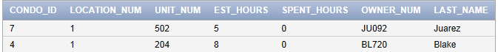

4.
SELECT FIRST_NAME, LAST_NAME
FROM OWNER
WHERE OWNER_NUM IN
(SELECT OWNER_NUM
FROM CONDO_UNIT
WHERE BDRMS = 3);
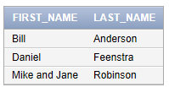

5.
SELECT FIRST_NAME, LAST_NAME
FROM OWNER
WHERE EXISTS
(SELECT *
FROM CONDO_UNIT
WHERE CONDO_UNIT.OWNER_NUM = OWNER.OWNER_NUM
AND BDRMS = 3);

6.
SELECT F.UNIT_NUM, S.UNIT_NUM
FROM CONDO_UNIT F, CONDO_UNIT S
WHERE F.SQR_FT = S.SQR_FT
AND F.UNIT_NUM < S.UNIT_NUM
ORDER BY F.UNIT_NUM, S.UNIT_NUM;
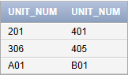

7.
SELECT SQR_FT, CONDO_UNIT.OWNER_NUM, LAST_NAME, FIRST_NAME
FROM CONDO_UNIT, OWNER
WHERE CONDO_UNIT.OWNER_NUM = OWNER.OWNER_NUM
AND LOCATION_NUM = '1';
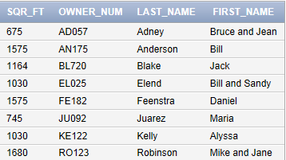

8.
SELECT SQR_FT, CONDO_UNIT.OWNER_NUM, LAST_NAME, FIRST_NAME
FROM CONDO_UNIT, OWNER
WHERE CONDO_UNIT.OWNER_NUM = OWNER.OWNER_NUM
AND LOCATION_NUM = '1'
AND BDRMS = 3;
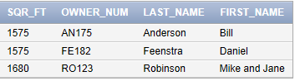

9.
SELECT LOCATION_NUM, UNIT_NUM, CONDO_FEE
FROM CONDO_UNIT, OWNER
WHERE CONDO_UNIT.OWNER_NUM = OWNER.OWNER_NUM
AND CITY = 'Bowton'
UNION
SELECT LOCATION_NUM, UNIT_NUM, CONDO_FEE
FROM CONDO_UNIT
WHERE BDRMS = 1;
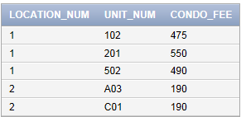

10.
SELECT LOCATION_NUM, UNIT_NUM, CONDO_FEE
FROM CONDO_UNIT, OWNER
WHERE CONDO_UNIT.OWNER_NUM = OWNER.OWNER_NUM
AND CITY = 'Bowton'
AND LOCATION_NUM IN
(SELECT LOCATION_NUM
FROM CONDO_UNIT
WHERE BDRMS = 1);
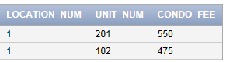

11.
SELECT LOCATION_NUM, UNIT_NUM, CONDO_FEE
FROM CONDO_UNIT, OWNER
WHERE CONDO_UNIT.OWNER_NUM = OWNER.OWNER_NUM
AND CITY = 'Bowton'
AND LOCATION_NUM NOT IN
(SELECT LOCATION_NUM
FROM CONDO_UNIT
WHERE BDRMS = 1);
No data found

12.
SELECT SERVICE_ID, CONDO_ID
FROM SERVICE_REQUEST
WHERE EST_HOURS > ANY
(SELECT EST_HOURS
FROM SERVICE_REQUEST
WHERE CATEGORY_NUM = 5);
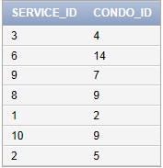

13.
SELECT SERVICE_ID, CONDO_ID
FROM SERVICE_REQUEST
WHERE EST_HOURS > ALL
(SELECT EST_HOURS
FROM SERVICE_REQUEST
WHERE CATEGORY_NUM = 5);
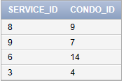

14.
SELECT CONDO_UNIT.CONDO_ID, SQR_FT, OWNER_NUM, SERVICE_ID,
EST_HOURS, SPENT_HOURS
FROM CONDO_UNIT, SERVICE_REQUEST
WHERE CONDO_UNIT.CONDO_ID = SERVICE_REQUEST.CONDO_ID
AND CATEGORY_NUM = 4;
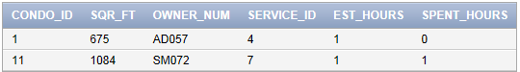

15.
SELECT CONDO_UNIT.CONDO_ID, SQR_FT, OWNER_NUM, SERVICE_ID,
EST_HOURS, SPENT_HOURS
FROM CONDO_UNIT
LEFT JOIN SERVICE_REQUEST
ON CONDO_UNIT.CONDO_ID = SERVICE_REQUEST.CONDO_ID
AND CATEGORY_NUM = 4;
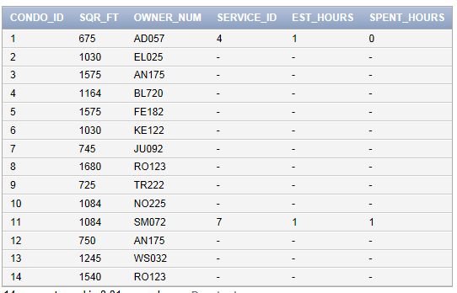

16. [Critical Thinking]
SELECT CONDO_UNIT.CONDO_ID, SQR_FT, OWNER_NUM, SERVICE_ID,
EST_HOURS, SPENT_HOURS
FROM SERVICE_REQUEST
RIGHT JOIN CONDO_UNIT
ON CONDO_UNIT.CONDO_ID = SERVICE_REQUEST.CONDO_ID
AND CATEGORY_NUM = 4;

Exercise 15 uses a left outer join and and Exercise 16 uses a right outer join. Both commands retrieve rows that do not match. The difference occurs in which table you list first.

